**Question 1 : What is REST?**  
Answer : REST is an architectural style of developing web services which take advantage of ubiquity of HTTP protocol and leverages HTTP method to define actions. REST stands for *REpresntational State Transfer*.  
  
  
**Question 2 : What is RESTFul Web Service?**  
Answer : There are two popular way to develop web services, using SOAP (Simple Object Access Protocol) which is XML based way to expose web services and second REST based web services which uses HTTP protocol. Web services developed using REST style is also known as [RESTful Web Services](https://click.linksynergy.com/fs-bin/click?id=JVFxdTr9V80&subid=0&offerid=323058.1&type=10&tmpid=14538&RD_PARM1=https%3A%2F%2Fwww.udemy.com%2Frest-web-services-using-java-ee%2F" \t "_blank).

**Why REST is better than SOAP?**

Now that you know some differences between REST and SOAP web services, let's summarize our reasons of *why REST is better choice* for modern day web service requirement :  
  
1. REST can be consumed by any client  e.g. Java, C++, Python client and even a web browser with Ajax and JavaScript.  
  
2. REST is lightweight as compared to SOAP, it doesn't require CPU consuming XML parsing and it also consumes less bandwidth because unlike SOAP, REST doesn't require a SOAP header for every message.  
  
3. SOAP is an old technology, all modern technical giant are using REST e.g. Google, Twitter, and Flickr.  
  
4. REST is easy to learn, its just nouns and verbs. If you already know HTTP methods then its even easier.  
  
5. Java has excellent support for RESTFul web services, well it also has good support for SOAP web services but you have lots of choices here e.g. Jersey, RESTLet etc.

**Summary - RESTful vs SOAP Web Service**

Here is a nice summary of key differences between REST and SOAP style web services :

[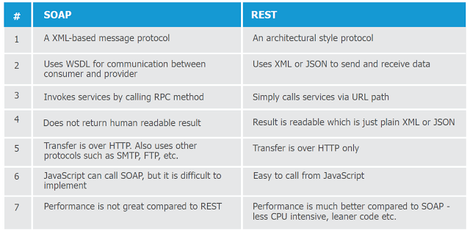](http://www.shareasale.com/m-pr.cfm?merchantID=53701&userID=880419&productID=546412655)